Smart blind control system

Prototype installation and operating

Content

Оглавление

Overview 3

Installation procedure 3

Room controller 3

Motion detector 6

Remote sensor module 6

Motor remote control 9

User interface 9

Sensors 10

Rules 10

Actions 11

Comments 12

# Overview

This document contains setup procedure and operating instruction for the demonstration prototype of smart blind control system.

Prototype consist of 3 parts:

1. Room controller module + motion detector
2. Remote sensor module
3. Radio-controlled motor (with remote control)



Figure 1. Smart blind control system (demonstration prototype)

Figure 1 shows how these parts are connected.

# Installation procedure

## Room controller

Room controller module contains inner temperature sensor, beeper and connector for motion detector. It also has integrated 433MHz receiver and transmitter modules to read and generate blind remote controller commands.

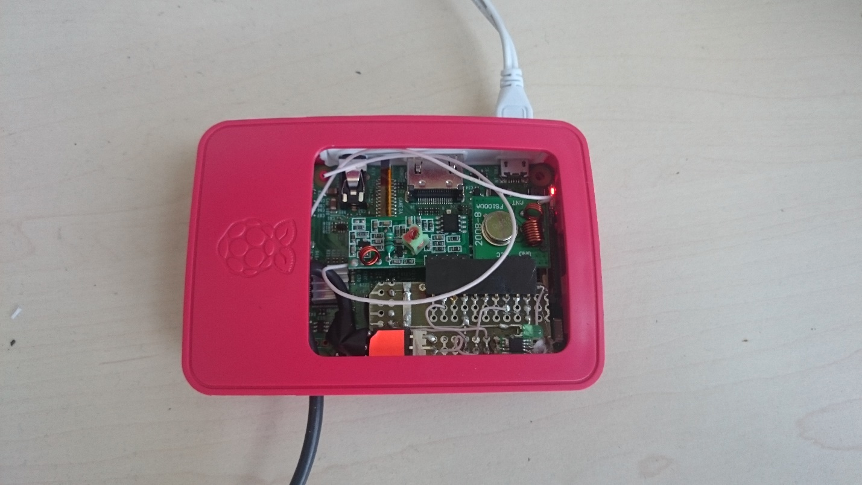

Figure 2. Room controller module

Room controller requires micro-USB power supply and network connection (Ethernet and Wi-Fi).

To setup Wi-Fi connection first you need to use wired network connection (via Ethernet cable). Connect network cable and power supply and after ≈1 minute you should hear a beep signal. Now you can perform Wi-Fi configuration procedure (you need a notebook connected to the same network):

1. Open internet browser on the PC
2. Type in the address field <http://roomsrv:8080>
3. You will be prompted to enter login information:

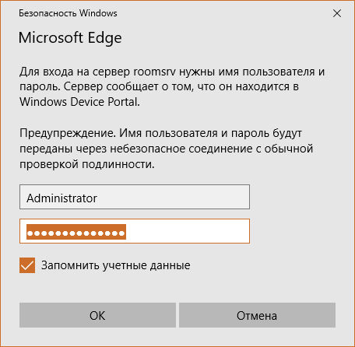

1. Enter user name “Administrator” and password “admin”
2. You should see device settings page: 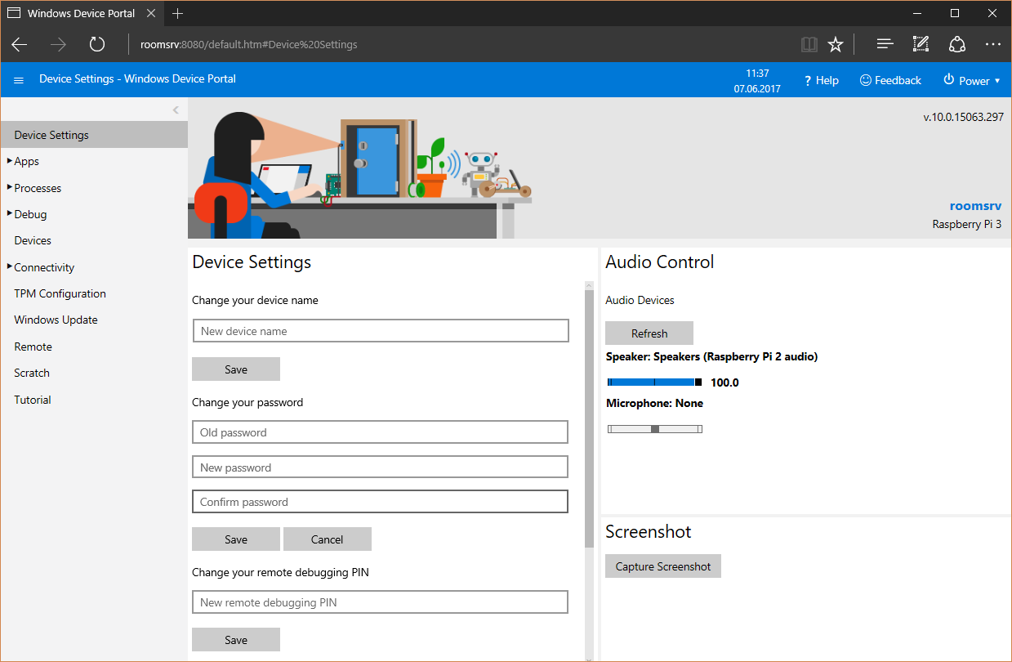
3. Go to the menu “Connectivity” on the left and select “Network” submenu: 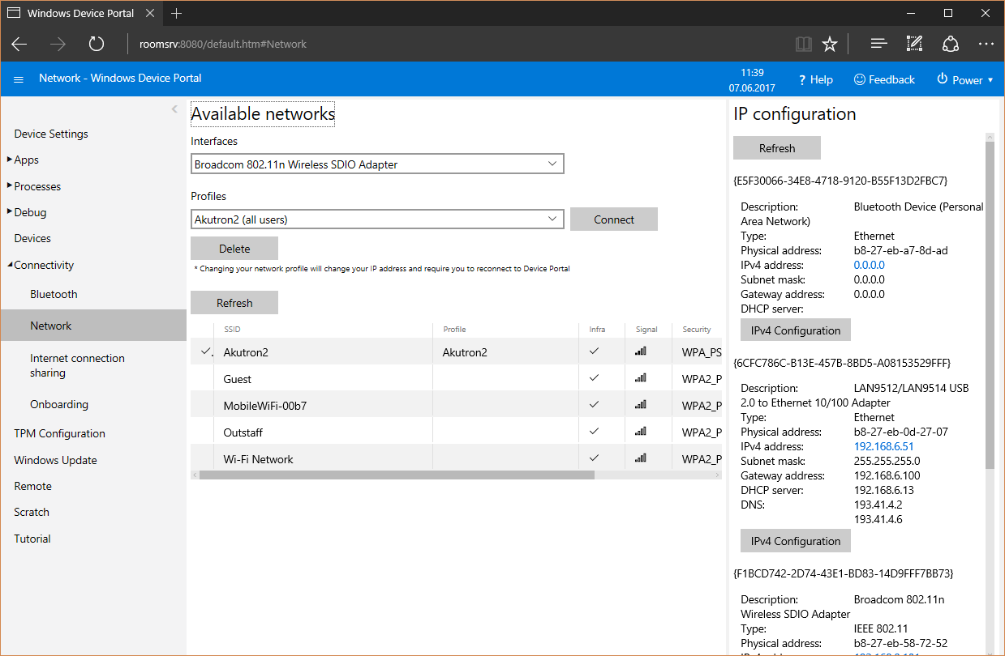
4. You should see list of available Wi-Fi networks
5. Select your network and enter network key if necessary
6. Press “Connect” button (check box “Create profile” should be checked):

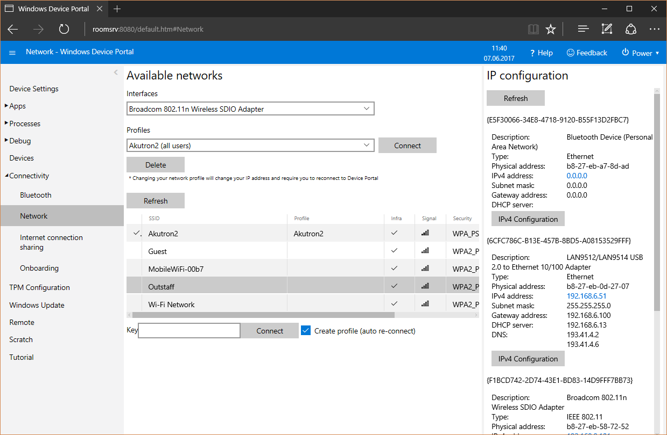

1. Now you can disconnect ethernet cable. Room controller will use Wi-Fi network.

Now you can try to open room status page via internet browser by typing <http://roomsrv> in the address field. You should see the room status page:

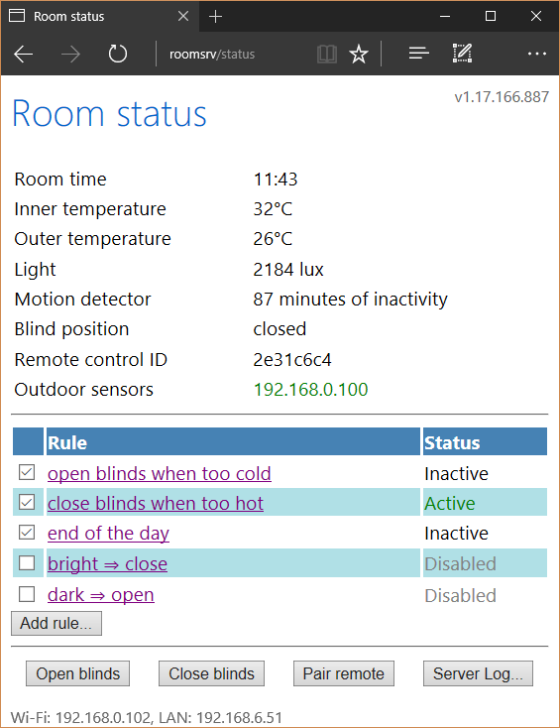

Figure 3. Room controller status page

Note: I chose a wrong place for the temperature sensor in the room controller. It is situated too close to the Raspberry Pi’s microcontroller. Because of that, inner temperature will always be few degrees higher than real value.

## Motion detector

Motion detector uses wired connection to the room controller. There is no special procedure required to setup the detector.

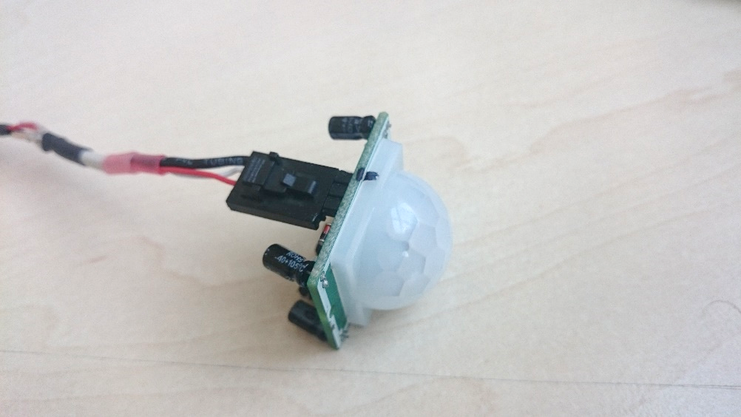

Figure 4. Motion detector

## Remote sensor module

Remote sensor module contains an outer temperature sensor and a light sensor. The module requires +5V power supply with micro-USB connector (USB connection is used only for power; no data transmission is performed via USB). For the test purposes, you can use one of the USB ports on the Raspberry Pi for powering the sensor module.

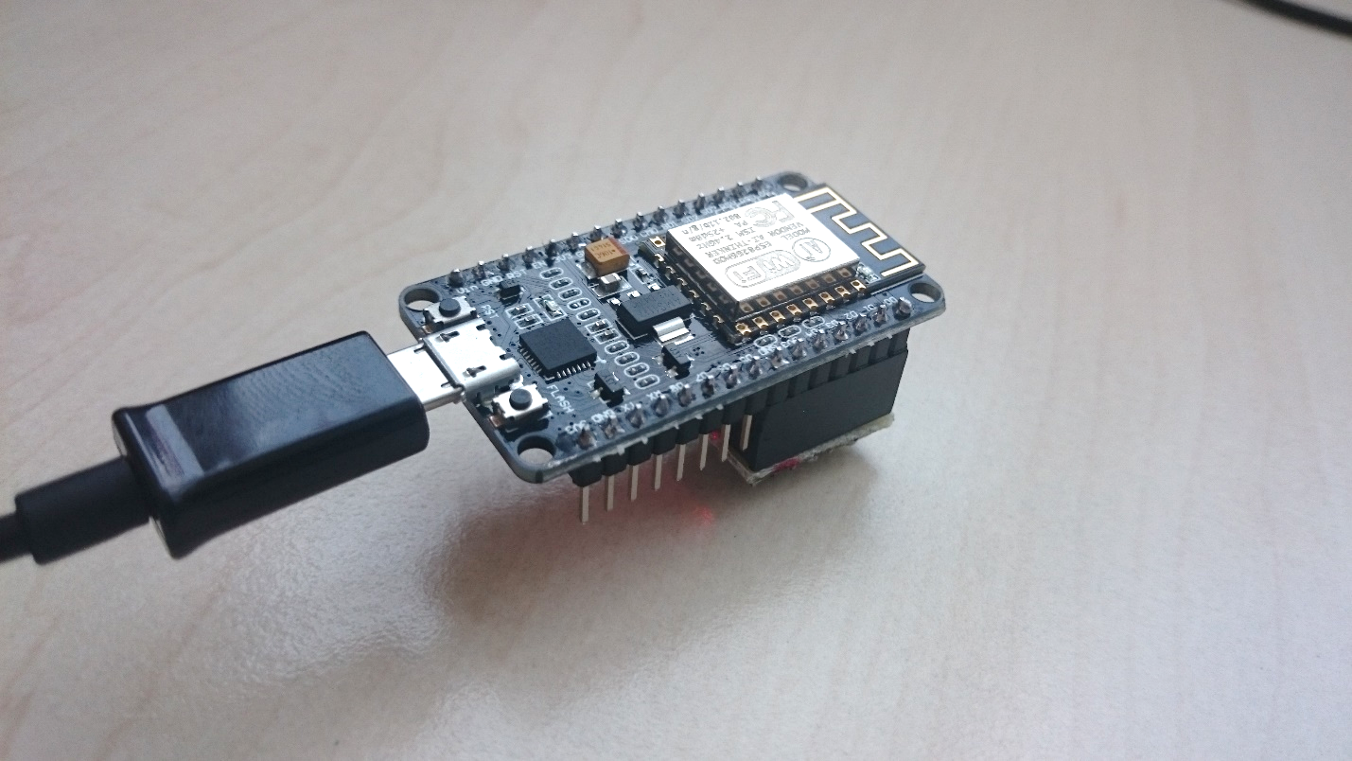

Figure 5. Remote sensor module

Right after powering up remote sensor module, it’s red LED starts to blink. This means that Wi-Fi connection is not configured. To perform configuration you need a notebook, phone or tablet. To configure Wi-Fi connection, you should:

1. Power up remote sensor module. Red LED starts to blink
2. Open Wi-Fi networks list on the phone and connect to the network “Motctrl_AP”
3. Open internet browser and type “192.168.4.1” in the address field
4. Wi-Fi configuration page should be displayed:

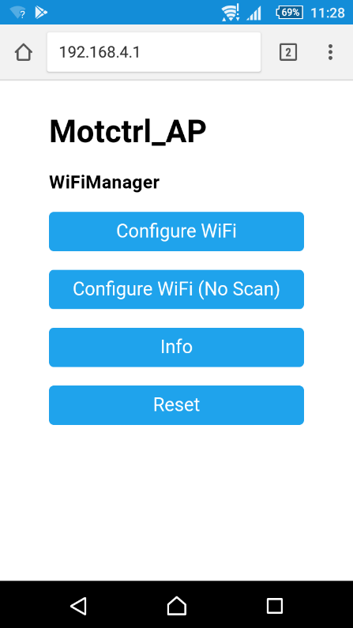

1. Press “Configure WiFi” button. You should see the list of available networks:

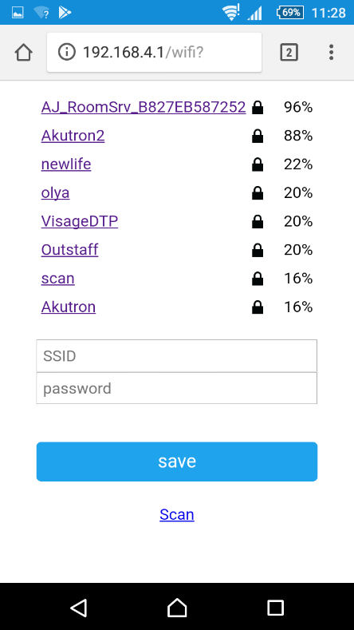

1. Select the network you want to use
2. Type password in the text field:

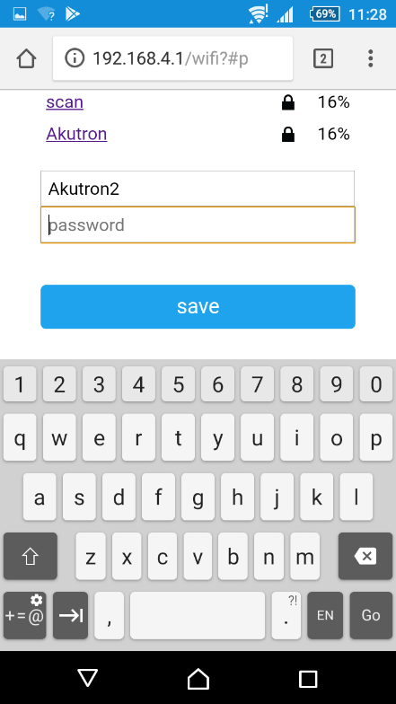

1. Press “Save button”
2. If network credentials are correct, after few seconds red LED should stop blinking

Network credentials are stored in the flash memory so you need not to perform this procedure again when power or connection is lost. However, this procedure should be performed again when network name or password changes.

Note: Take care of the light sensor position before you start to test the system. It should be set in a place where direct sun rays can reach the sensor (see Figure 6).

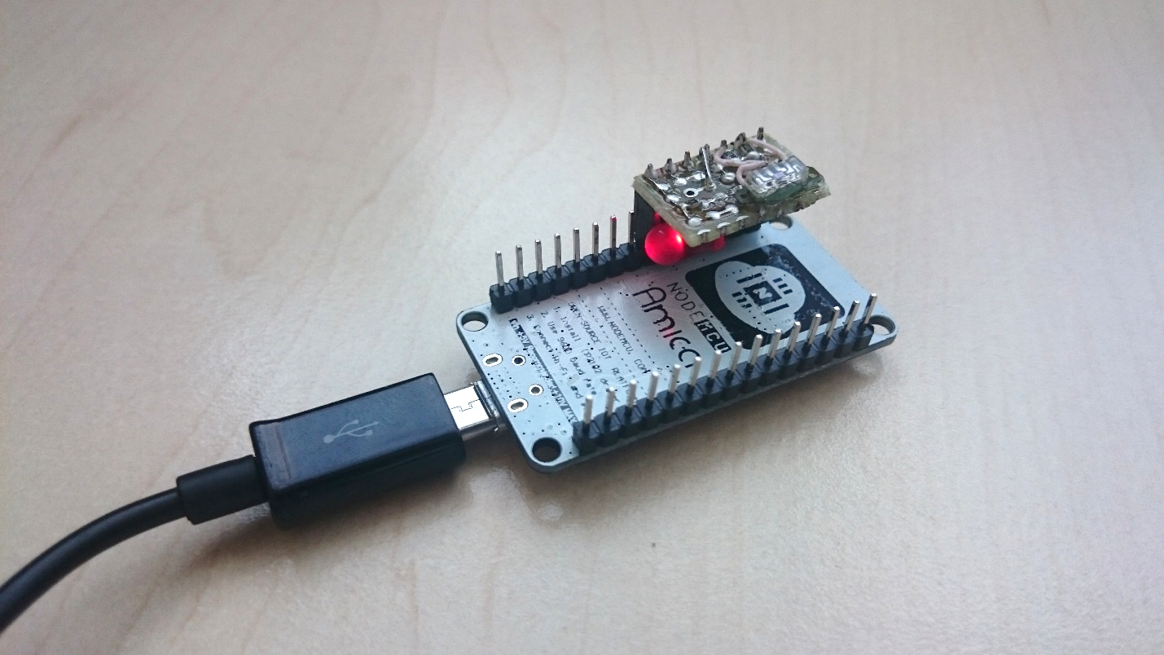

Light sensor

Figure 6. Light sensor position

## Motor remote control

Before room controller can operate the motor, it should be paired with corresponding remote control.

First of all, you must perform standard matching procedure between remote control and motor. Then you should pair remote control with room controller (Important: channel number on the remote control should be the same that was used to setup motor):

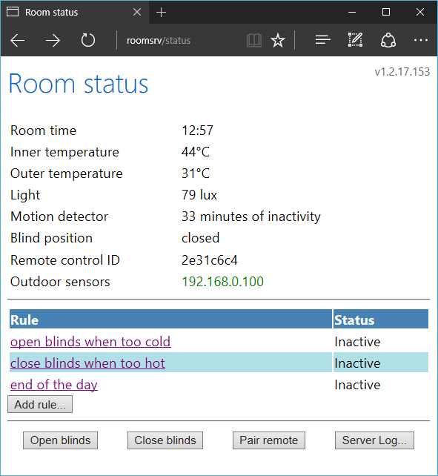

Figure 7. Pairing remote control

Open room status page in the web browser (<http://roomsrv>), press “Pair remote” button (see Figure 6) and follow the instructions. In case of success you should hear single beep and remote ID will be shown:

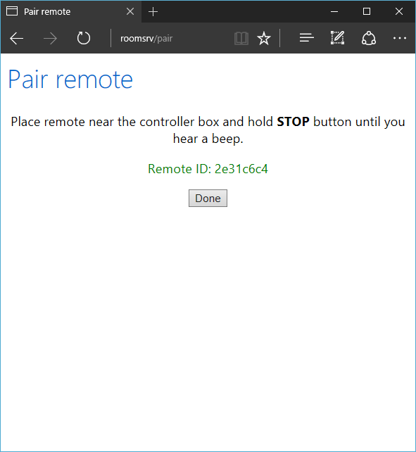

Figure 8. Pairing complete

After pairing is performed you can test sending commands to motor by pressing “Open blinds” and “Close blinds” buttons:



Figure 9. Blind control

# User interface

User can control the state of the room and perform some operations via web-browser. Just type <http://roomsrv> in address field (unfortunately, this works only on PCs; android/iOS devices must use IP address of the room controller, e.g. <http://192.168.0.100>).

Main page contains 3 areas:

* Sensor area
* Rules
* Actions

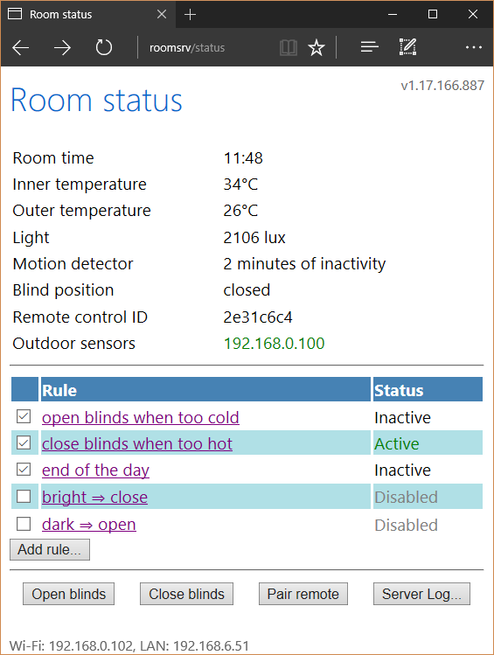

Sensors

Rules

Actions

Figure 10. Room status page

## Sensors

This area shows values of various sensors connected to the room controller as long as additional information, such as blind position or remote sensor module status. These values can be used to adjust blind control rules according to installation condition (for example, you can measure typical level of sun light or average temperature level and use them in the rules).

## Rules

This area contains list of available blind control rules and their status. Rule status is one of the following values:

* Inactive – rule condition is not met
* Active – rule condition is met
* Failed – error during evaluating rule condition or rule action
* Disabled – rule is turned off (can be changed by user by clicking checkbox on the left)



Figure 11. Rules control area

When you click on the rule name or press “Add rule…” button, new page is opened. There you can edit selected rule or add a new one.

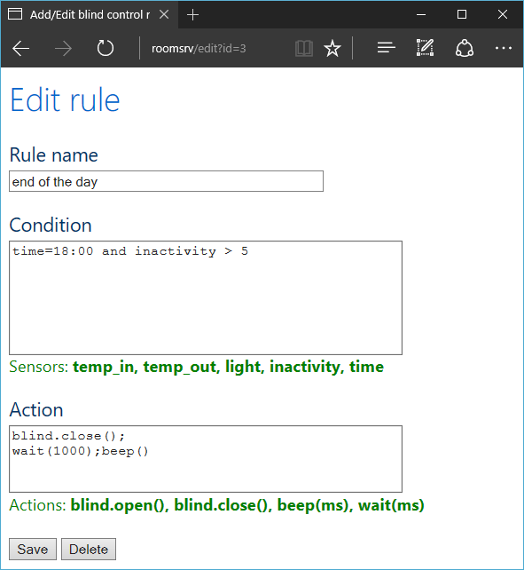

Figure 12. Edit rule page

Rule definition contains three fields: name, condition and action. Name is a plain text, you can put anything there. Condition and action are expressions that are evaluated during rule checking procedure.

In these expressions, you can use:

* sensor names (“temp_in”, “temp_out”, “light”, “inactivity” and “time”)
* sensor range control ([sensor].min, [sensor].max, [sensor].reset())
* integer (“1”, “5”, “42”, etc.) and time (“18:45”) constants
* mathematical operations (+, -, *, /, %)
* comparison operations (<, >, <=, >=, =, !=)
* logical operations (and, or, not)
* conditional expression (“light < 100 ? 0 : 1”)
* brackets “(” and “)”
* function calls (“blind.open()”, “blind.close()”, “beep([ms])”, “wait([ms])”)
* user variables (“last_temp = temp_in”)

Also, you can combine multiple expressions, separating them by semicolon.

Rule condition is met when condition expression is evaluated to non-zero value.

Rule action is evaluated only when rule condition is met.

Example of rule conditions and actions are shown in Table 1 and Table 2.

|  |  |
| --- | --- |
| Rule condition | Description |
| time=18:00 and inactivity > 5 | Time of the day is 18:00 and there was no activity in last 5 minutes |
| temp_out > temp_in + 10 | Outer temperature is more than 10 degrees higher than inner temperature |
| temp_out > prev_temp | Outer temperature is higher than value of variable “prev_temp” |
| temp_in > 20 and temp_in.min < 18 | Current internal temperature is higher than 20 degrees and it has fallen lower than 18 degrees since last reset |

Table 1. Rule condition examples

|  |  |
| --- | --- |
| Rule action | Description |
| blind.open() | Open the blind |
| blind.close() | Close the blind |
| light.reset() | Reset light sensor min/max range |
| beep(); wait(300); beep() | Make a beep, wait 300 milliseconds and make another beep |
| prev_temp = temp_out | Store outer temperature sensor value in the variable “prev_temp” |

Table 2. Rule action examples

## Actions

Action bar contains buttons that perform some operations:

* Open blinds – sends “Up” command to the motor
* Close blinds – sends “Down” command to the motor
* Pair remote – starts motor remote control pairing procedure
* Server log… – shows log of last operations

# Comments

Put your comments here…